Notes: Create a Jira ticket for this assignment, Provide detailed step-by-step instructions for the installation process along with proper evidence (Outputs, and screenshots). You may refer to YouTube tutorials or Google resources for guidance, and submit the challenge completion document by EOD.

- Launch one aws ec2 and install jenkins..

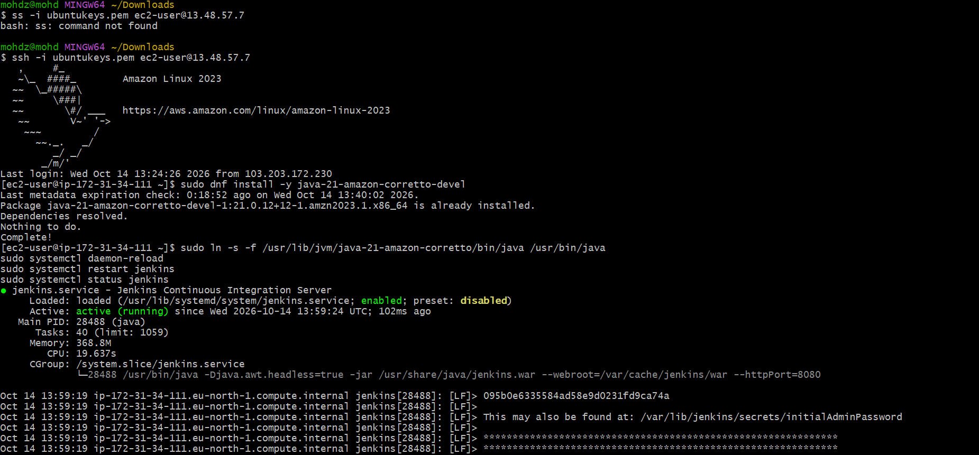

2 . Setup Apache Tomcat on Ubuntu Virtual Machine.

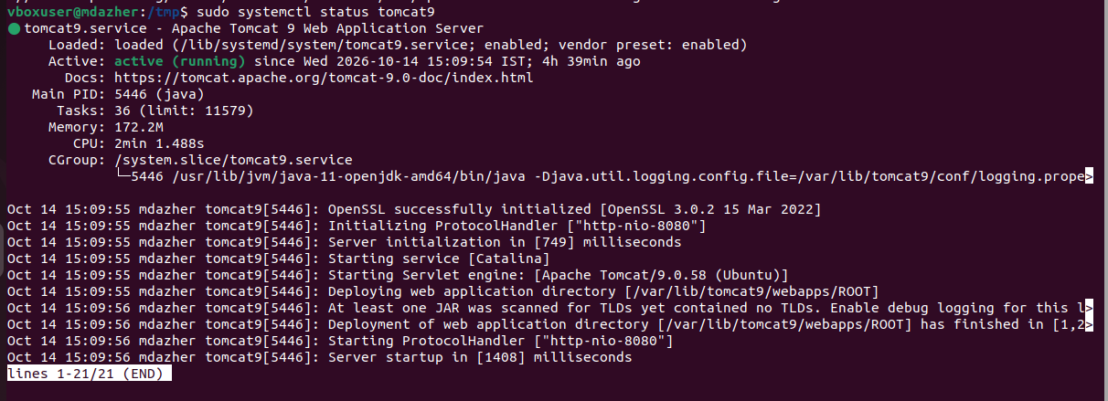

- Setup Docker Desktop on your local windows..

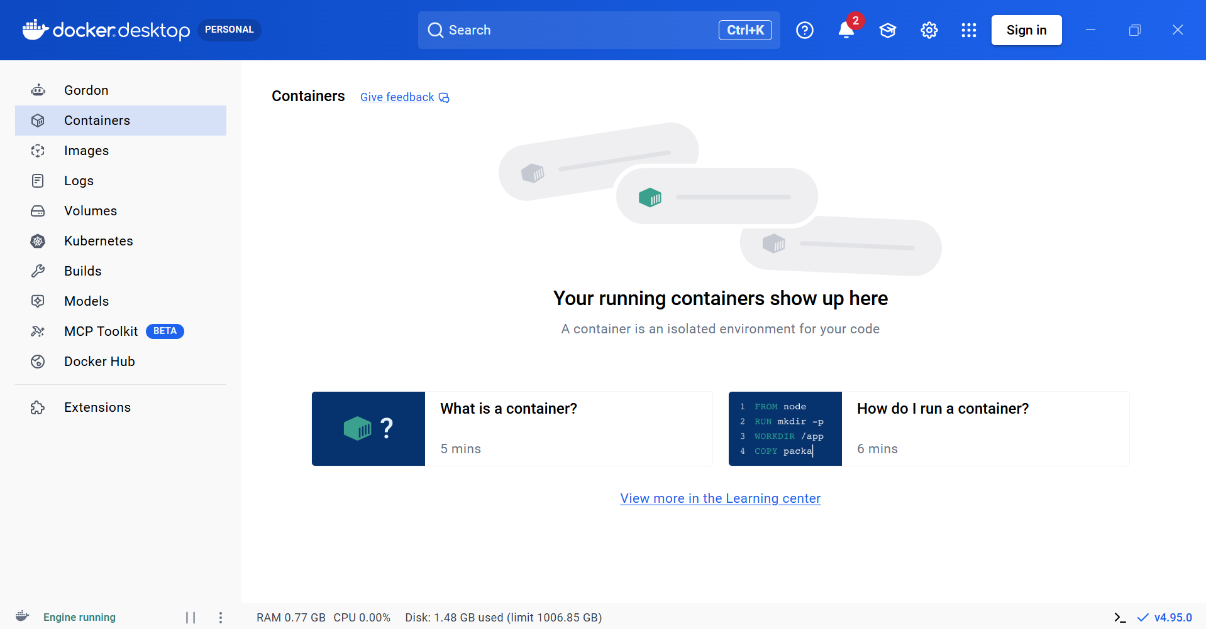

Log off only after completing all pending tasks and challenges till date.

